**App Name: GraduGate**

|  |  |  |  |  |  |  |
| --- | --- | --- | --- | --- | --- | --- |
| Forms | Data | | Tasks (what the user performs?) | Features (part of your app) | Social Interactions | Design for Diversity/ Value sensitive design |
| Phone/Mobile  Desktop  Tablet  Website | User Profiles:  Professor/advisors Information  Student’s Information  Student-Professor Interactions   * Text prompts * Portfolio * Meeting scheduler * Background Info | Word documents  10,611,800+ Document Stock Photos, Pictures & Royalty-Free Images - iStock  | Document icon, Signing document, Legal document  PDFs  PDF - Wikipedia  Text  Project Report  Project Report at best price in Pune | ID: 18558212897  Links  Student Resumes | Obtain a timeline/roadmap  Unlock the Power of Storytelling: Turn a Product Roadmap into a Thrilling  Narrative  Search for available professors/advisors  Sign Up and Log In  Find Professor area of interests  Lookup the professor previous works and publications  Contact info and contact section  Finding if the professor is open to work with the student | All the professor previous works and their publications.    Student portfolio  Four Creative Portfolio Ideas to Showcase Student Learning – Brennan  Consulting  Scheduling the meetup with professors  Submission section for proposal  Information on school specific | Discussion Forums on specific topics  Talking to an advisor    Announcements happening on campus/particular department related to Projects/ideas/Thesis  Customize their profile picture (PNG/JPEG or GIF)  profile circle" Icon - Download for free – Iconduck  Choose color of their profile/application?  Description about yourself along with your attached resume. | Multilingual Support  Text to speech  Text to Speech using Natural Language Processing | by TULSHIDAS LINGAYAT |  Medium  Light/Dark Mode  Day night switch vector icon. Dark mode, light mode switch button. Mobile  app interface design concept. Stock Vector | Adobe Stock  Color palette for color blind people    User-Generated Content  Customizable UI |

**Random Sketches of the application:**

Welcome Screen

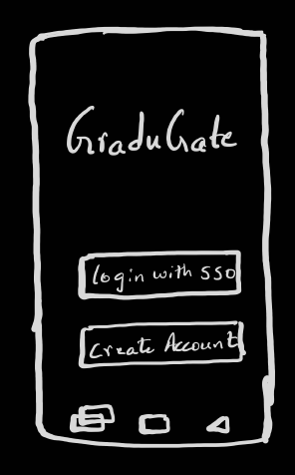

Once the user selects Login with SSO, it redirects to Sac State student login page

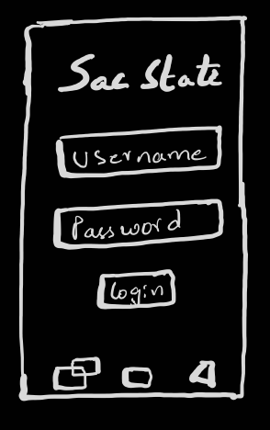

Students can view the professor’s information, their Area of interests, previous and recent publications and the current projects that the students are working under that advisor, and the courses that the advisor teaches and their portfolios.

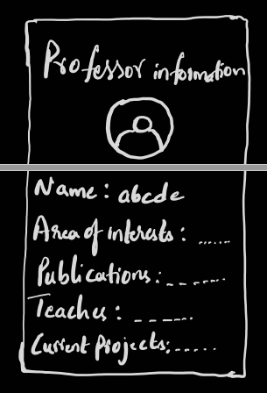

Similarly, students can access their profile and input their courses they completed, current courses they are enrolled into, their portfolio, any publications they have published during their academic term.

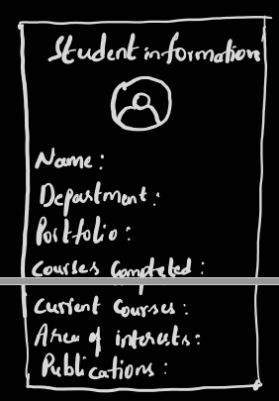

Students can upload their project proposals for professor’s review and below is the page where they upload and submit the document.

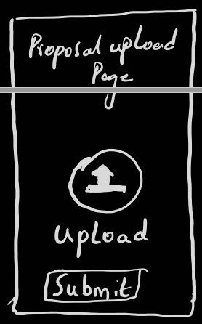

Students can enter/post their timeline in the application by editing the structure/upload a csv file with their timeline. It segregates and display the data here.

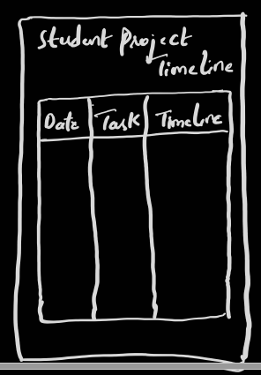

Students can schedule their meetings with the professor’s/advisors based on the availability by selecting the date and time. Professors’ availability will be displayed on their profile. Notification email will be sent to both professor and student emails with the meetings details.

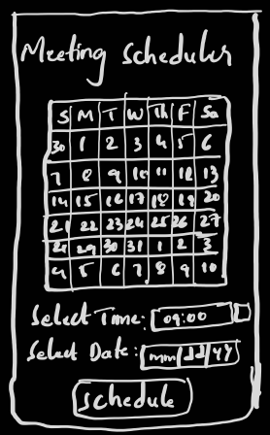

Students can discuss/chat with their project advisors just in case if they have any academic issues/topics related to the project.

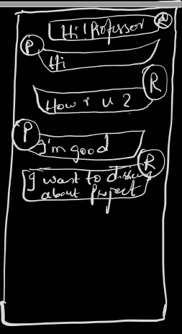

If the professor/advisor or students finds any interesting topic that they want to discuss, there is an open discussion form that anyone can post the topic and start their discission.

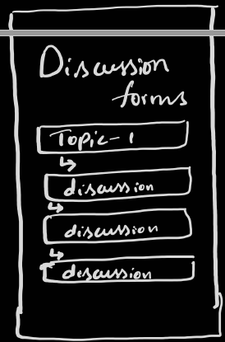

Students can access My Account and select the options for the settings or view/modify their profile. About section consists of the application details, application version, developer details, feedback.

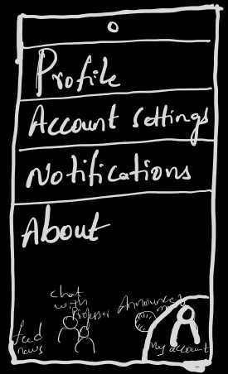

Account settings consists of students account details and change/view them.

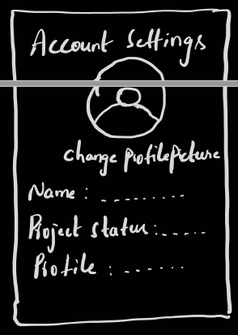

The application, we design is diverse in nature and can be used by everyone and can even customize the UI based on their user experience.

